NIFTY VIEW

The Nifty continued its southward journey for second consecutive day on Wednesday and finished the choppy day. Funds and retail investors indulged in profit-booking along with weak global cues. Investors took note of the OECD report, which stated that India’s economy will accelerate in 2015/16 but will fail to attain the heady growth rates of the past decade without sweeping structural reforms. Market traded near its neutral line in the first half however witnessed bloodbath in second half and ended below its crucial 8,400 level as European counterparts seen selling pressure during the trade. Investors’ sentiments were further dented on report that FPIs sold shares worth a net Rs 101.98 cr. Besides, some investors took money off the table as there were no immediate triggers for the markets However, losses remained capped with global rating agency Fitch Ratings’ statement that India's economic growth is expected to pick up to 5.6 percent in the current fiscal on account of structural reforms being rolled-out by the government. Meanwhile, RBI governor Raghuram Rajan has said that India will focus on sustainable economic growth and developed economies should do the same.

TREND: Trend is up and can turn down if close will below 8361

After upside breakout, Nifty again enter in a range bound territory in which it was trading more than a week. Yesterday Nifty again took support of its DRV which stands at 8361 which indicate trend is still up so one should hold long position if have with the SL of 8361 on closing basis. Nifty could touch to 8465-8477-8500-8600 while downside Nifty has support at 8361-8320-8240.

Nifty likely to open flat following on global cues.

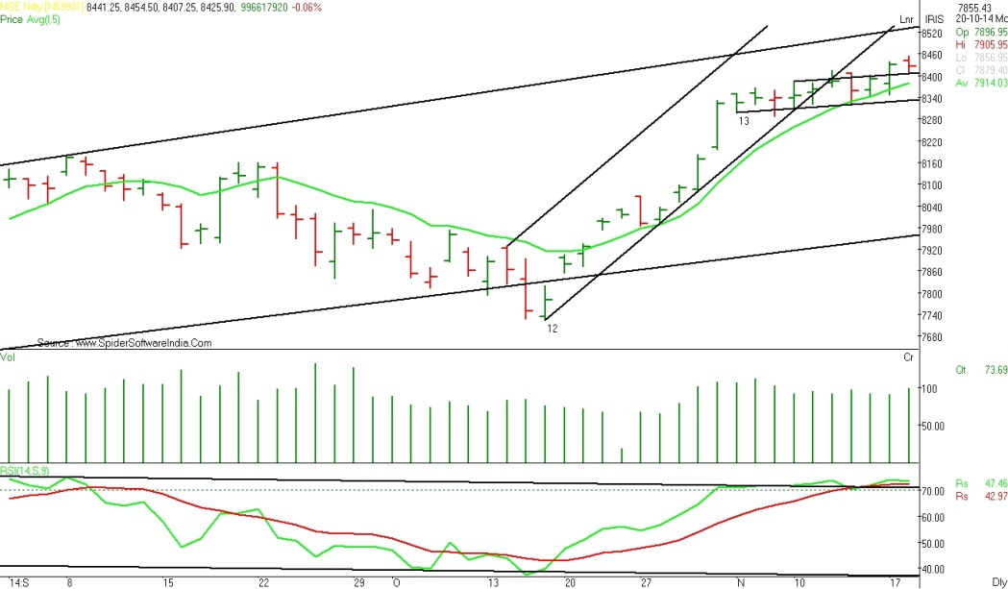

FORPURELY INTRA-DAY TRADERS: If Fut. Nifty Trades above open and 8425 then expect a rise towards 8451-8470 Traders can trade long with stop loss of 8405. If Nifty Trades below open and 8390 then expect a decline towards 8365-8350 to be tested. For Short Trade the stop loss can be 8410.

As on 19/11/2014 8:50 AM



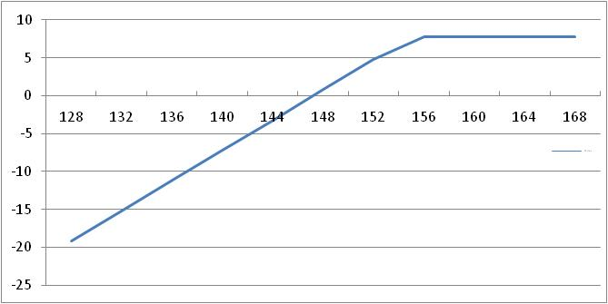



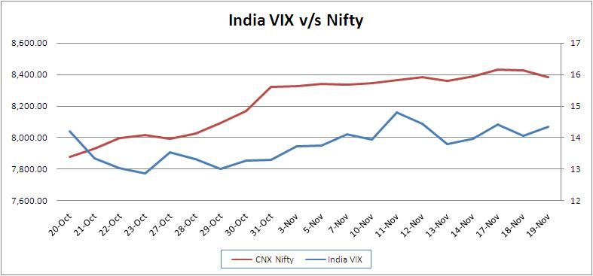

The VIX increased by 1.99% and reached to 14.34, The Nifty decreased by 43.60 points or 0.52% to settle at 8,382.30. Nifty November 2014 futures closed at 8409.55 on Wednesday at a premium of 27.25 points. While Nifty December 2014 futures ended at 8456.55 at a premium of 74.25 points. Nifty November futures saw contraction of 0.62 mn units, taking the total outstanding OI to 21.99 mn units.

The Nifty PCR finally stood at 1.40. The top five scripts with highest PCR on OI were DRREDDY 1.76, EICHER 1.74, DLF 1.47, BANKBARODA 1.25 and ZEEL 1.18.

***STRATEGY CORNER***







For Private Circulation Only

